| **Challenge Name:** | Ticket Data Extraction BOT |
| --- | --- |
| **Software’s Required** | UiPath Studio |
| **Domain** |  |

**Problem Statement:**

Ticket Data Extractor BOT reads the ticket emails and extracts the data followed by adding the extracted in the master Excel file.

**Problem Description:**

**·** Read the Input Email (You can use any mailbox Gmail, Outlook). You should consider 3 emails for testing each with different priority (High, Medium, Low).

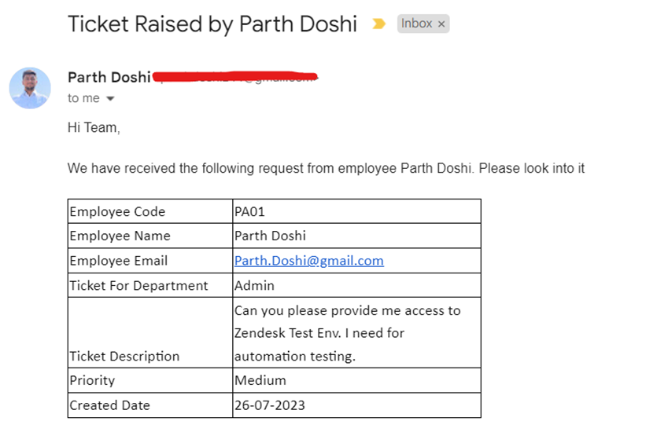

·       BOT should extract all the data from table (Regex should be used)

·       After the data is extracted an Excel File should be created with file name TicketData.xlsx

·       Within the Excel file the Sheet name should be the Department name in the ticket if the sheet already exists then append data or else create the sheet with the Department Name in the ticket.

·       The cell colour of the priority column will be based on the priority type as mentioned below

High – Cell colour Red

Medium – Cell colour Yellow

Low – Cell colour Grey

·       Save the Excel File once the data has been added.

**Evaluation Criteria**

Expected output is the below Excel File shown in the screenshot - 100

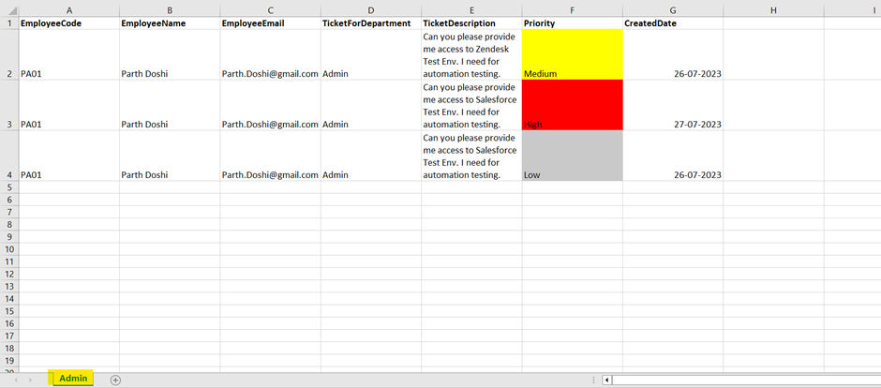

**Do’s & Don’ts**

**·** Do use Excel Modern Activities

·        Do use proper naming convention for variables and arguments.

·        Do validate your workflow with Workflow Analyzer and it should have 0 Errors / Warnings.

·        Do not give default values use assign statement wherever necessary.

**Reference Links:**

**Excel Modern Activities:** [**https://docs.uipath.com/activities/other/latest/productivity/studiox-excel**](https://docs.uipath.com/activities/other/latest/productivity/studiox-excel)

**Email Activities:** [**https://docs.uipath.com/activities/other/latest/productivity/about-the-mail-activities-pack**](https://docs.uipath.com/activities/other/latest/productivity/about-the-mail-activities-pack)

**Regex Activities:** [**https://docs.uipath.com/activities/other/latest/workflow/regex-builder-wizard**](https://docs.uipath.com/activities/other/latest/workflow/regex-builder-wizard)